

Program: Post Graduate Diploma (PGD) in Data Science
Course Title: Data Science Project
Course: PGDDS 203
Project Title: Real-Life Project: Predictive Analytics

Submitted by:
Student Name | ID
Md. Sahariar Sahen | 905253005

Submitted to:
Ahmed Imran Kabir,
Assistant Professor
School of Business & Economics (SoBE),
United International University (UIU)
Dhaka, Bangladesh

Table of Contents
1. Introduction 4
2. Dataset Description 5
2.1. Stock Prices Dataset 5
2.2. Sales Dataset 5
2.3. Waiter Tips Dataset 5
2.4. Overall Dataset Structure 6
3. Model Selection and Implementation 6
3.1. LSTM for TECHCORP Stock Price Prediction 6
3.2. Holt-Winters Exponential Smoothing for North Store Sales 7
3.3. Linear Regression Baseline for Waiter Tips 7
3.3.1. Linear Regression with Additional Features 7
3.3.2. Ridge Regression 8
3.3.3. Random Forest Regression 8
3.4. Summary of Models Actually Tested 8
4. Stock Price Prediction Using LSTM 9
5. North Store Sales Forecasting 11
6. Waiter Tips Regression and Model Comparison 13
7. Deployment Demonstration 14
8. Limitations and Improvement Opportunities 15
9. How the Stock and Sales Models Could Be Deployed 15
10. Conclusion 16
11. Documentation and GitHub Presentation 16

List of Figures
Figure 1: TECHCORP closing-price series used for the LSTM analysis. Place this figure immediately after the paragraph describing the historical price pattern. 9
Figure 2: LSTM training and validation loss across epochs. 9
Figure 3: Actual versus LSTM-predicted TECHCORP closing price during the later test period. 10
Figure 4: North Store daily sales over the observed period. 10
Figure 5: North Store seasonal decomposition showing observed, trend, seasonal, and residual components. 11
Figure 6: Holt-Winters forecast for the final 60-day test period of North Store sales. 12
Figure 7: Relationship between total bill and tip, separated by meal time. 13
Figure 8: Comparison of test-set R² across waiter-tip models. 14

List of Tables
Table 1: Overview of the Synthetic Datasets and Their Modelling Focus 5
Table 2: Model Selection and Rationale for the Predictive Analytics Problems 8
Table 3: TECHCORP LSTM Model Configuration and Performance Results 8
Table 4: Waiter Tips Regression Model Comparison and Test Performance 13
Table 5: Deployed Waiter Tips Pipeline: Predictions on Unseen Inputs 14

Introduction
Predictive analytics is an important approach for extracting useful patterns from historical data and using those patterns to estimate future or unknown outcomes. In this project, predictive analytics is applied to three different types of prediction problems using a synthetic dataset: stock-price prediction, sales forecasting, and waiter-tip prediction. Since these problems have different data structures and predictive objectives, different modelling techniques are applied to each problem.
The first part of the project focuses on TECHCORP stock-price prediction. Historical closing-price observations are used to predict the following day's closing price. As stock-price observations are ordered sequentially over time, an Long Short-Term Memory (LSTM) neural network is implemented to capture patterns from previous observations and generate next-day predictions. A time-based evaluation approach is used so that the model is assessed on later observations rather than randomly selected observations from the same time period.
The second part addresses North Store sales forecasting. Daily sales observations are examined to identify the underlying trend and recurring seasonal behaviour. The analysis considers the weekly pattern in the sales series and applies Holt-Winters exponential smoothing, which is appropriate for forecasting a time series containing both trend and seasonality. The model is evaluated using a later period of the sales series that was not used for model fitting.
The third part focuses on waiter-tip prediction, which is treated as a regression problem. The analysis begins with a simple baseline model using total_bill as the predictor. The model is then refined by incorporating additional available variables and by testing different regression approaches, including Linear Regression, Ridge Regression, and Random Forest Regression. This progressive modelling approach allows the effect of additional features and different model structures on prediction performance to be examined.
In addition to model development and evaluation, the project includes a deployment component for the waiter-tip prediction task. A preprocessing-and-model pipeline is saved as a single file, subsequently loaded, and used to generate predictions for two new observations. This demonstrates the practical use of a trained predictive model for making predictions on previously unseen inputs. The main objective of this report is to interpret the predictive modelling results rather than simply present model outputs. The report evaluates the stock-price and sales forecasting models using Root Mean Squared Error (RMSE) and evaluates the waiter-tip regression models using R² and RMSE. It also examines the effect of model refinement, explains why time-based evaluation is important for sequential data, discusses limitations of the modelling approach, and considers how the developed models could be deployed in a practical setting.
All analyses and interpretations presented in this report are based on the synthetic dataset, project notebook, and generated model outputs used in this project. No external dataset has been introduced. The report therefore focuses on the modelling decisions, predictive performance, and findings obtained from the supplied synthetic data. The overall project follows the required structure of model selection and implementation, evaluation and comparison, documentation, result interpretation, and deployment.

Dataset Description
The predictive analytics project uses a synthetic dataset provided in an Excel workbook, containing three separate datasets corresponding to three prediction problems: stock price prediction, sales forecasting, and waiter tips regression. The datasets are organized into three worksheets: Stock_Prices, Sales_Data, and Waiter_Tips.

Stock Prices Dataset
The Stock_Prices sheet contains historical stock-market data for three companies: TECHCORP, ENERGYX, and RETAILCO. The dataset includes daily observations with the following variables:
- Date – date of the stock observation
- Ticker – company identifier
- Open – opening stock price
- High – highest price during the day
- Low – lowest price during the day
- Close – closing stock price
- Volume – trading volume
For the predictive modelling task, the analysis focuses on TECHCORP and uses its closing price as the target variable for next-day stock price prediction.

Sales Dataset
The Sales_Data sheet contains daily sales observations for four stores: North, South, East, and West. The variables include:
- Date – date of the sales observation
- Store – store identifier
- Sales – daily sales value
The dataset is used for time-series forecasting. In the analysis, the North Store is selected for modelling. Its daily sales data are examined to identify underlying trend and weekly seasonal patterns before applying the forecasting model.

Waiter Tips Dataset
The Waiter_Tips sheet contains 450 restaurant transaction observations. It includes information about the bill, tip amount, customer characteristics, dining period, and party size. The variables are:
- total_bill – total restaurant bill
- tip – tip amount, which is the prediction target
- sex – customer's sex
- smoker – whether the customer is a smoker
- day – day of the week
- time – dining period
- size – number of people in the dining party
This dataset is used to develop and compare regression models for predicting the tip amount. The analysis begins with total_bill as a baseline predictor and then incorporates additional categorical and numerical features to examine whether prediction performance can be improved.

Overall Dataset Structure
Table 1: Overview of the Synthetic Datasets and Their Modelling Focus
Dataset | Main Purpose | Key Variables | Modelling Focus
Stock_Prices | Stock price prediction | Date, Ticker, Open, High, Low, Close, Volume | TECHCORP closing price
Sales_Data | Sales forecasting | Date, Store, Sales | North Store sales
Waiter_Tips | Tip prediction | Total bill, Tip, Sex, Smoker, Day, Time, Size | Tip amount
The three datasets therefore represent three different predictive analytics problems: sequential prediction of stock prices, time-series forecasting of sales, and regression-based prediction of restaurant tips. This structure allows different modelling approaches to be applied according to the characteristics of each dataset.

Model Selection and Implementation
The model selection was based on the characteristics of each prediction problem and the structure of the available data. Three different predictive tasks were addressed: TECHCORP stock-price prediction, North Store sales forecasting, and waiter-tip prediction. The models were selected to reflect the sequential nature of the stock and sales data and the tabular structure of the waiter-tip data.

LSTM for TECHCORP Stock Price Prediction
An LSTM (Long Short-Term Memory) neural network was selected for the TECHCORP stock-price prediction task because the closing-price observations form a time-dependent sequential dataset. The objective was to use historical closing prices to predict the next day's closing price. The LSTM approach was appropriate because the model can process sequences of observations and learn temporal patterns from previous values. In this analysis, a 20-day sliding window was used so that the model could learn from the recent historical price sequence when generating the next-day prediction.
A time-based train-test split was used because stock-price prediction is a forecasting problem. The model should learn from earlier observations and then be evaluated on later observations rather than using randomly mixed historical and future data.
Model-selection rationale:
The LSTM was chosen because the stock-price problem is sequential and the prediction depends on the historical order of observations. Its recurrent architecture provides a suitable framework for learning temporal patterns from the previous 20 closing-price observations.

Holt-Winters Exponential Smoothing for North Store Sales
Holt-Winters Exponential Smoothing was selected for the North Store sales forecasting task because the sales series showed two important characteristics: an underlying trend and a repeating weekly seasonal pattern. Before fitting the forecasting model, the sales series was examined using seasonal decomposition with a 7-day period. This was used to identify the weekly structure of the daily sales data. Holt-Winters was selected because it is specifically designed to model time-series behaviour involving level, trend, and seasonality. Therefore, it provides a suitable approach for the observed North Store sales pattern. The forecasting evaluation was also performed using a later time period rather than randomly selected observations, maintaining the chronological structure of the forecasting problem.
Model-selection rationale:
Holt-Winters was chosen because the North Store sales series contains a clear weekly seasonal pattern together with an overall trend, making a trend-and-seasonality-based forecasting method appropriate for the data.

Linear Regression Baseline for Waiter Tips
For the waiter-tip prediction problem, the analysis began with Linear Regression using total_bill as the only predictor. This model was selected as the baseline because the analysis showed a strong positive relationship between total_bill and tip. Starting with a simple model provided a reference against which the subsequent refined models could be evaluated. The baseline therefore established whether more features and more complex algorithms were actually necessary to improve prediction.
Model-selection rationale:
Linear Regression was selected as the baseline because it is simple, interpretable, and provides a clear reference for measuring the benefit of subsequent model refinements.

Linear Regression with Additional Features
The next model extended the baseline Linear Regression by incorporating the additional available variables:
- total_bill
- sex
- smoker
- day
- time
- size
This model was implemented to determine whether information beyond the total bill could improve the prediction of tip amount.

Model-selection rationale:
The full-feature Linear Regression model was selected as the first refinement to test whether incorporating additional customer, dining, and party-size information could improve prediction compared with the simple total_bill baseline.

Ridge Regression
Ridge Regression was then tested using the expanded feature set. The purpose of introducing Ridge Regression was to examine whether regularization could improve the generalization of the linear model when multiple predictors were included. Because Ridge retains the linear structure of Linear Regression while applying a penalty to the coefficients, it provided a direct comparison with the ordinary Linear Regression model.
Model-selection rationale:
Ridge Regression was selected to test whether regularization could provide more stable or better-generalized predictions than ordinary Linear Regression using the same expanded feature set.

Random Forest Regression
The final waiter-tip model tested in the notebook was Random Forest Regression. Random Forest was selected as a different modeling approach from the linear models. While Linear and Ridge Regression model relationships using a linear functional form, Random Forest can represent nonlinear relationships and interactions among predictors.
This allowed the analysis to determine whether a more flexible machine-learning model could capture additional patterns in tip amounts that were not adequately represented by the linear approaches.
Model-selection rationale:
Random Forest was selected to test whether a nonlinear ensemble-based approach could improve prediction beyond the linear models by capturing more complex relationships among the available features.

Summary of Models Actually Tested
Table 2: Model Selection and Rationale for the Predictive Analytics Problems
Problem | Model actually tested | Reason for selection
TECHCORP stock prediction | LSTM | Suitable for sequential and time-dependent observations
North Store sales forecasting | Holt-Winters Exponential Smoothing | Suitable for trend and weekly seasonality
Waiter tips | Linear Regression — baseline | Simple, interpretable reference model
Waiter tips | Linear Regression — all features | Tests whether additional predictors improve the baseline
Waiter tips | Ridge Regression | Tests the effect of regularization
Waiter tips | Random Forest Regression | Tests whether nonlinear relationships improve prediction

Stock Price Prediction Using LSTM
The stock-price experiment selects TECHCORP and uses its closing price as the modeling variable. The notebook constructs sliding windows in which the previous 20 observations are used to predict the following closing price. The data are split chronologically into training and later test sequences. The LSTM architecture contains 32 LSTM units followed by Dense layers of 16 and 1 unit, giving 4,897 trainable parameters.
Table 3: TECHCORP LSTM Model Configuration and Performance Results
Item | Result
Input window | Previous 20 closing prices
Train/test sequence counts | 884 / 221
LSTM architecture | 32 LSTM → 16 Dense → 1 output
Optimizer | Adam
Loss | Mean Squared Error
Epochs / batch size | 15 / 16
Reported test RMSE | $2.43

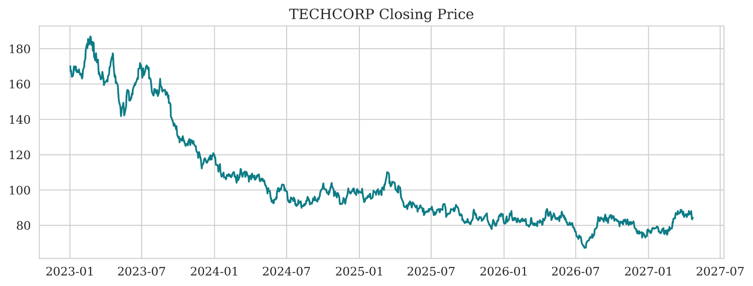
Figure 1: TECHCORP closing-price series used for the LSTM analysis. Place this figure immediately after the paragraph describing the historical price pattern.
Figure 1 shows substantial movement in the synthetic TECHCORP closing price over the available period. The series begins at a substantially higher level, declines over the middle portion of the record, and later remains mainly in the lower price range. The LSTM therefore has to learn both longer-term movement and short-term variation from the historical closing-price sequence.
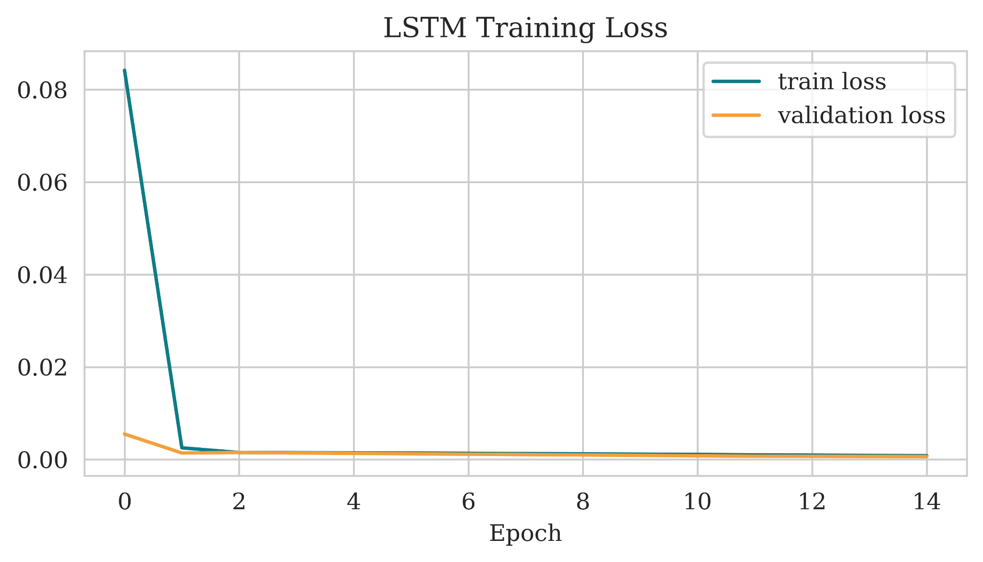
Figure 2: LSTM training and validation loss across epochs.
The loss curve falls sharply during the first few epochs and then becomes comparatively stable. This indicates that the model learns the dominant structure of the training sequence quickly. The displayed curves do not show a strong late-stage divergence between training and validation loss.
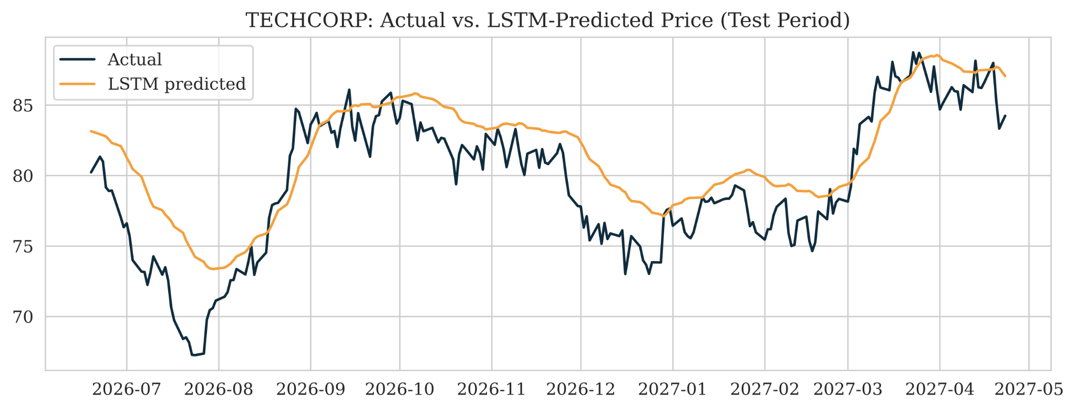
Figure 3: Actual versus LSTM-predicted TECHCORP closing price during the later test period.
The actual-versus-predicted plot shows that the LSTM follows the broad direction of the test-period series. The prediction line is smoother than the actual line, so the model captures the underlying movement more readily than individual short-term fluctuations. The reported RMSE is $2.43. Relative to the approximate test-period mean price of $79.49, this corresponds to an error magnitude of roughly 3.1% of the mean test-period price.
A methodological limitation should be noted. The notebook fits the MinMaxScaler to the complete price series before the train/test split, so the scaling parameters incorporate information from the later period. In addition, the test data are supplied as validation data during training. A stricter experiment would fit the scaler only on training data and keep a separate validation set before evaluating once on an untouched final test set.

North Store Sales Forecasting
The sales experiment selects the North Store and models its daily sales using Holt-Winters exponential smoothing. The exploratory plots show both a changing underlying level and a highly visible repeating weekly pattern. The series is decomposed with a seven-day seasonal period, after which an additive trend and additive seasonality forecast is fitted.
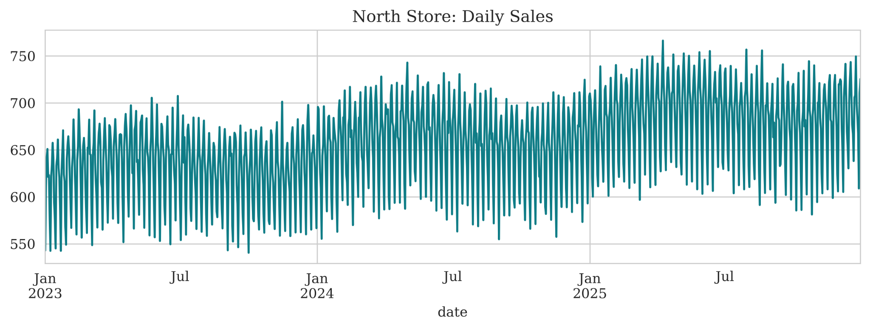
Figure 4: North Store daily sales over the observed period.
The daily series displays repeated high and low values throughout the three-year period. The annual mean level also rises from approximately 629.15 in the first year to 656.64 in the second and 684.14 in the third, showing an overall upward movement in the synthetic sales level.
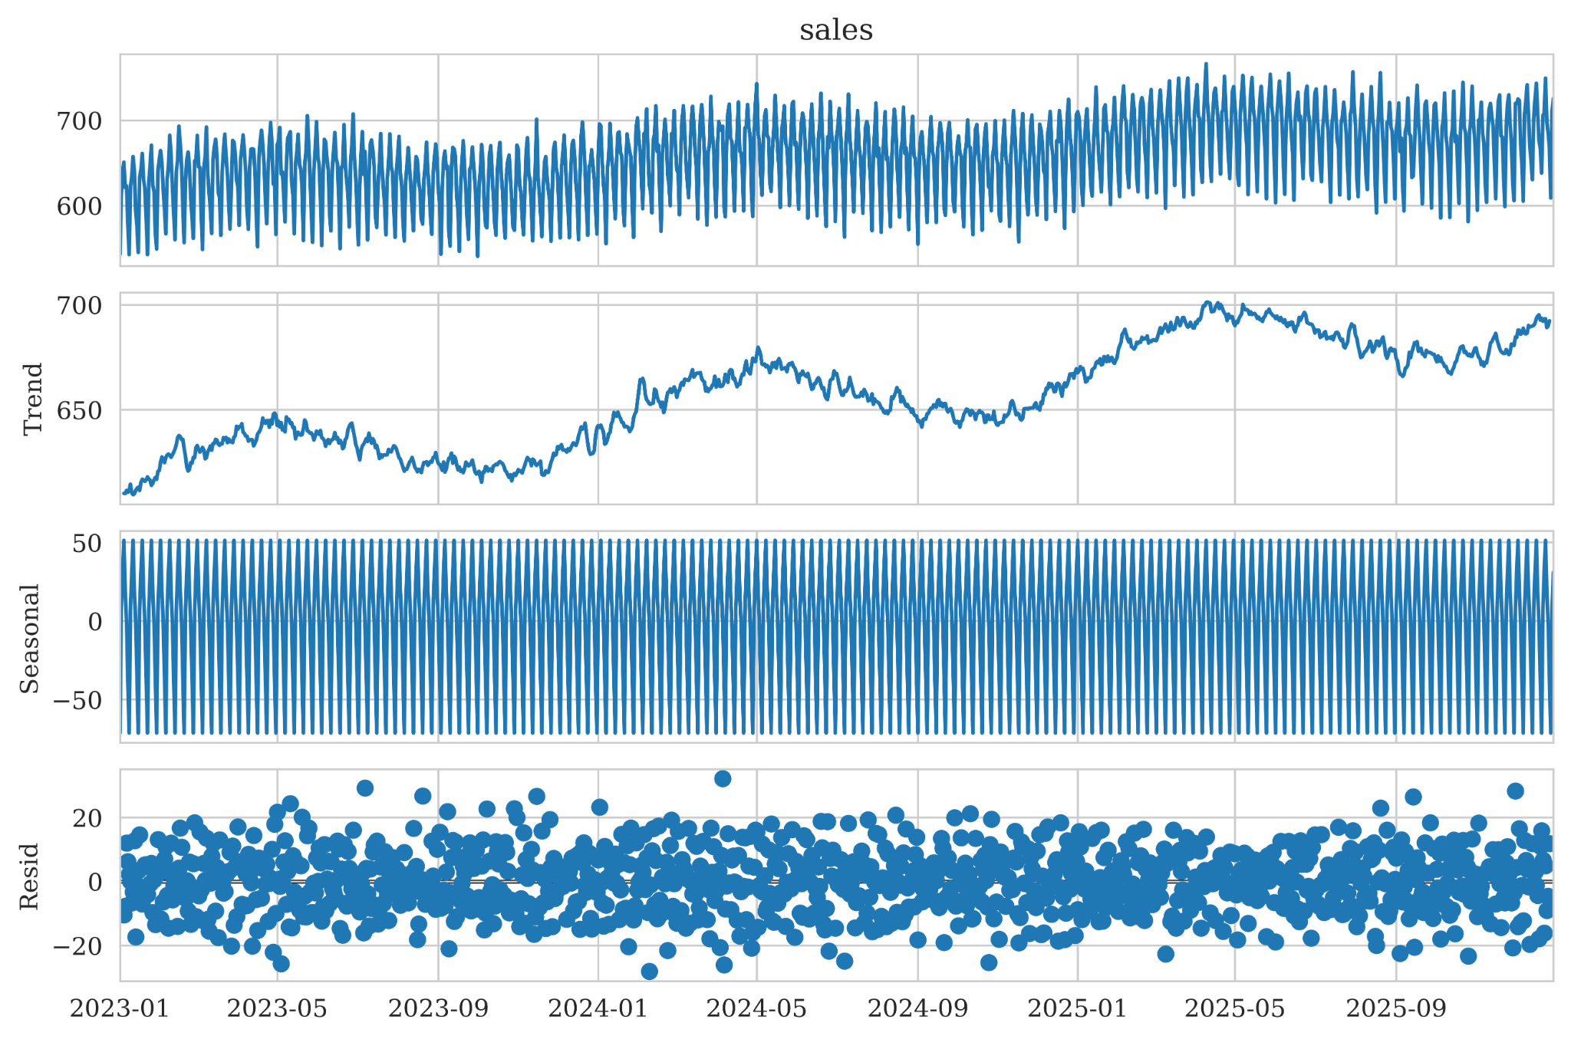
Figure 5: North Store seasonal decomposition showing observed, trend, seasonal, and residual components.
The decomposition separates the observed sales into trend, seasonal, and residual components. The trend component shows periods of growth and temporary decline but an overall upward direction. The seasonal component shows a strong weekly pattern, with approximately +51.27 units on Wednesday and −71.28 units on Sunday in the displayed decomposition. The residual component fluctuates around zero, indicating that the trend and weekly seasonal structure account for a substantial portion of the systematic variation.
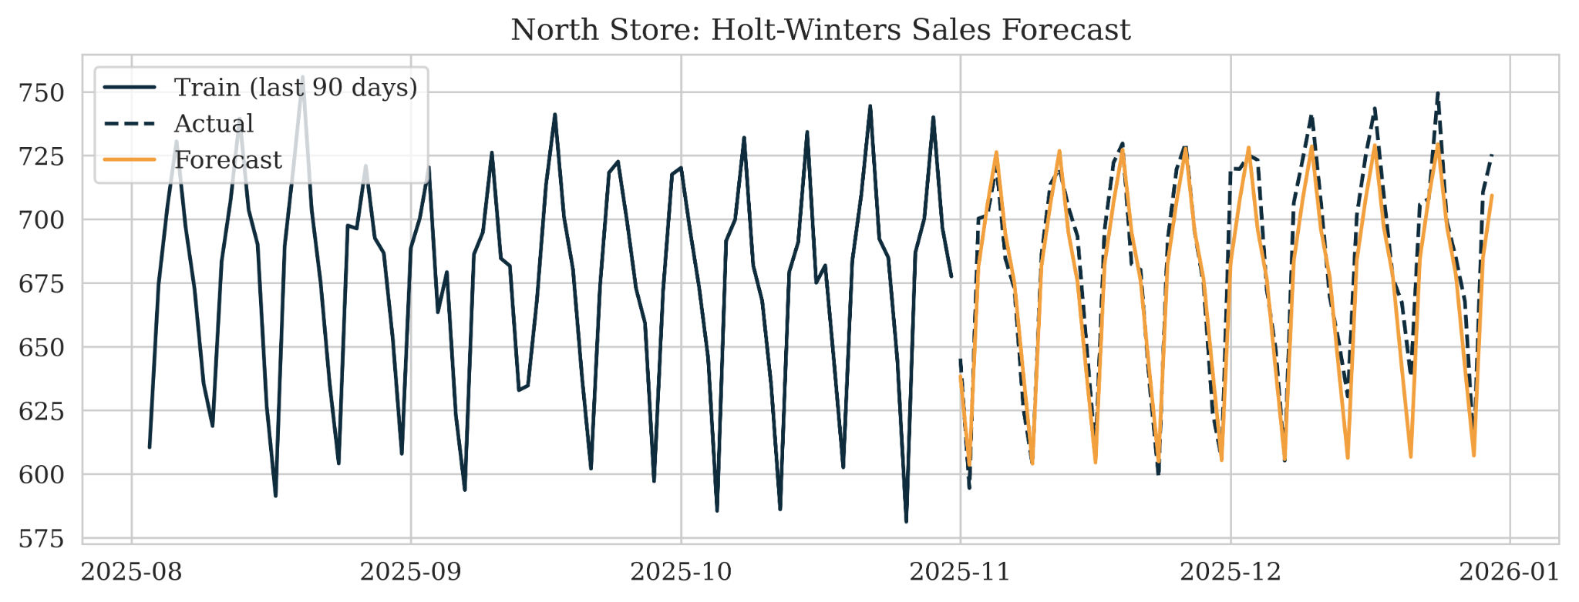
Figure 6: Holt-Winters forecast for the final 60-day test period of North Store sales.
The Holt-Winters forecast reproduces the repeating weekly pattern visible in the actual test period. Forecast peaks and troughs occur at approximately the expected times, although the forecast does not reproduce every individual extreme value. The reported test RMSE is 14.1 sales units per day. This result indicates that the model captures the systematic trend-seasonality structure while leaving some day-to-day variation unexplained.

Waiter Tips Regression and Model Comparison
The waiter-tip problem uses tip amount as the target and considers total bill, sex, smoker status, day, time, and party size as predictors. The analysis begins with a simple total-bill-only baseline and then evaluates models that use the broader feature set.
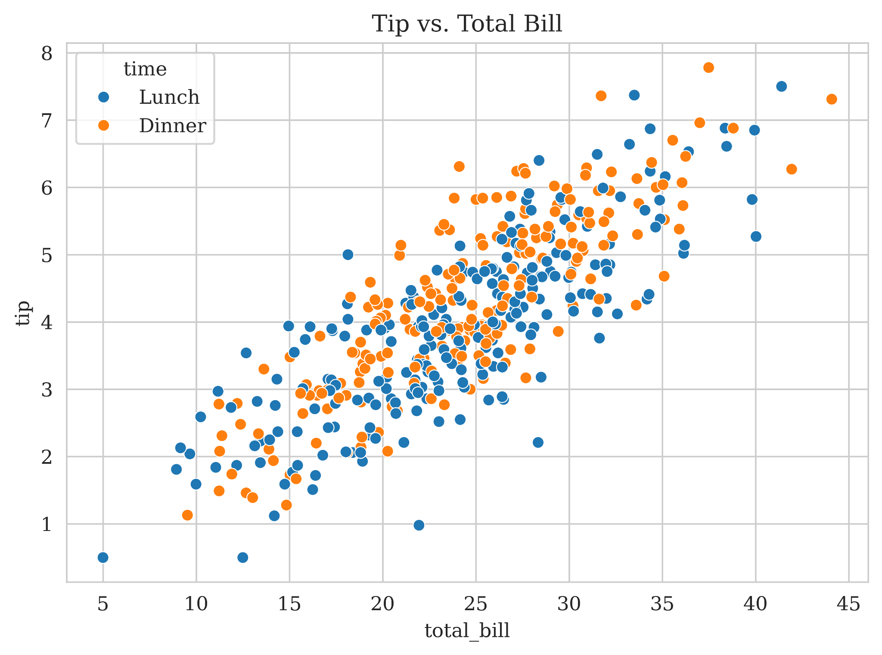
Figure 7: Relationship between total bill and tip, separated by meal time.
The scatter plot shows a clear positive relationship between total bill and tip. The notebook reports a correlation of approximately 0.814 between these variables. This strong relationship explains why the simple bill-only baseline already achieves substantial predictive performance.
Table 4: Waiter Tips Regression Model Comparison and Test Performance
Model | R² (test) | Interpretation
Baseline (total bill only) | 0.602358 | Strong baseline using the dominant numerical predictor
Linear Regression (all features) | 0.620043 | Small improvement after adding all features
Ridge Regression (all features) | 0.620350 | Almost identical to ordinary linear regression
Random Forest | 0.535779 | Lower test-set R² than the simpler models

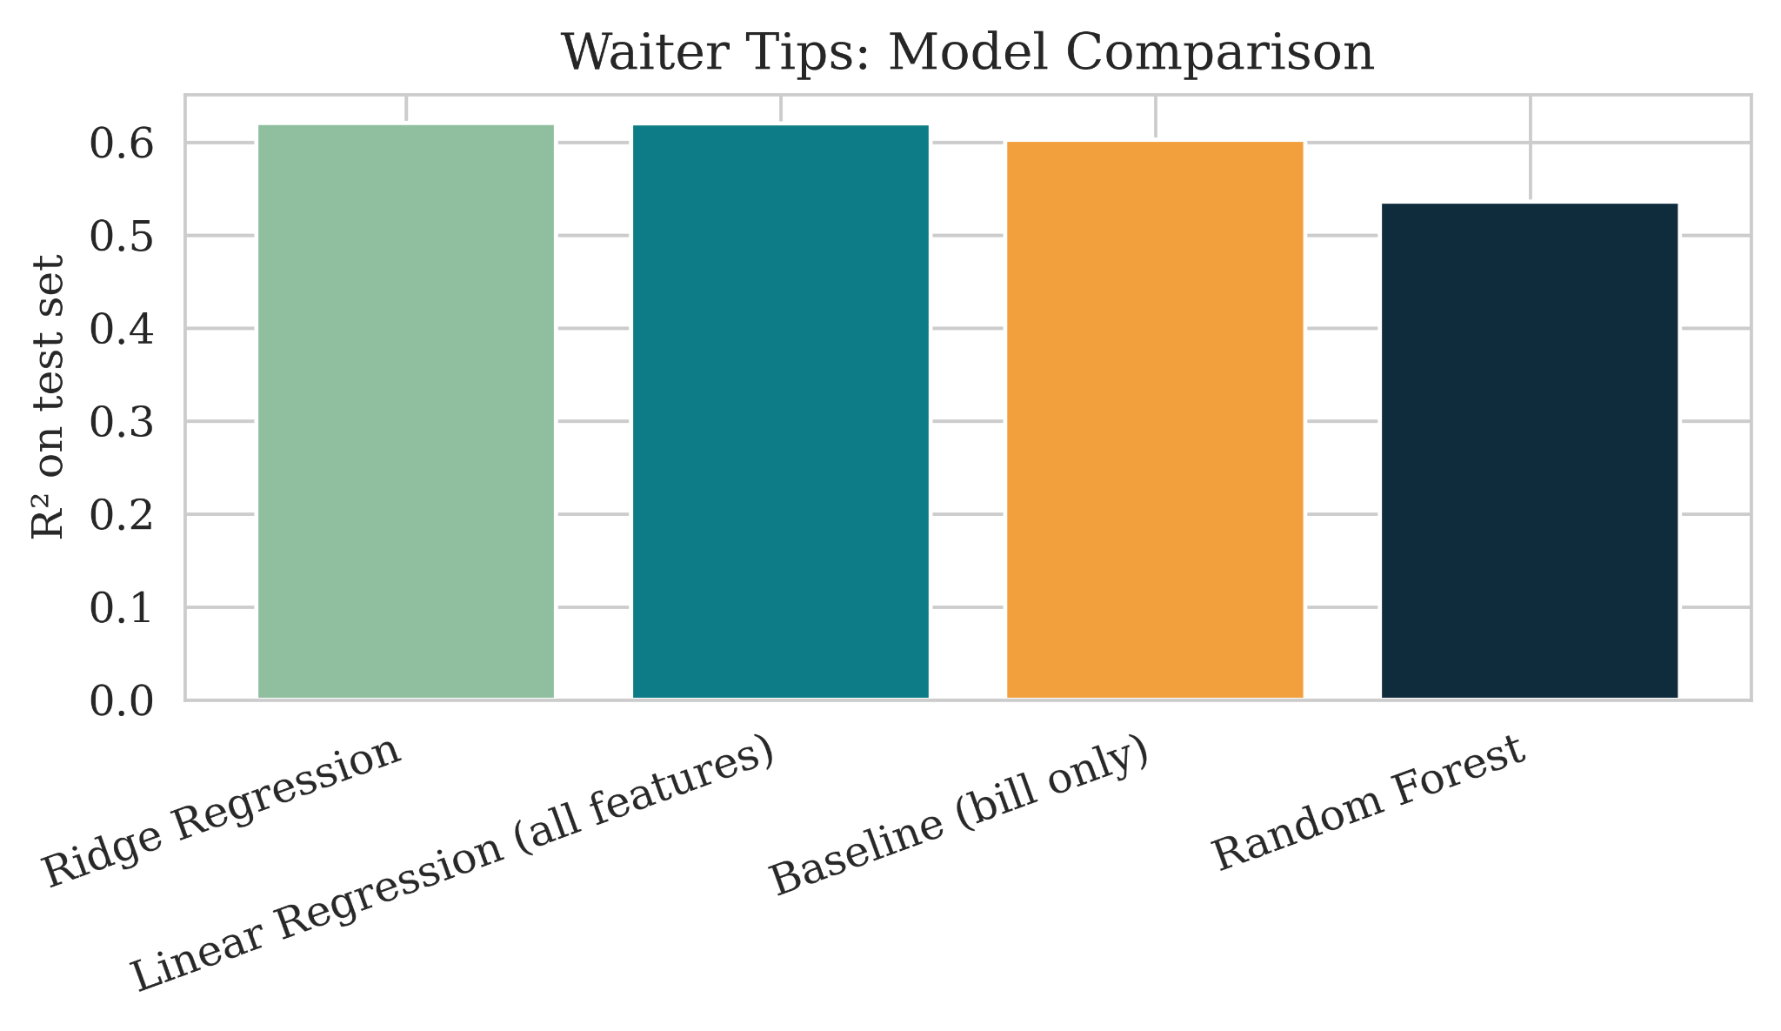
Figure 8: Comparison of test-set R² across waiter-tip models.
The model comparison shows that adding the categorical variables and party size improves R² from 0.602 to about 0.620, an increase of roughly 0.018 R² points. Ridge regression produces almost exactly the same performance as ordinary Linear Regression, indicating little additional benefit from the regularization used in this experiment. Random Forest produces a lower R² of 0.536, showing that the more flexible nonlinear model did not improve the held-out prediction result.
The result suggests that total bill is the dominant predictor among the variables tested. Party size has a very small simple correlation with tip in the notebook, while differences associated with meal time and day are comparatively small. These observations do not mean the other variables are irrelevant in every setting; they describe their predictive contribution within this synthetic dataset and this particular modeling setup.

Deployment Demonstration
The notebook saves the waiter-tip preprocessing and model together as a single pipeline file named `tips_pipeline.joblib`. The pipeline is then loaded and applied to two new observations. One observation with a total bill of 45.00 produces a predicted tip of 6.95, while another with a total bill of 18.50 produces a predicted tip of 2.58.
Table 5: Deployed Waiter Tips Pipeline: Predictions on Unseen Inputs
New input | Predicted tip
$45.00; Male; No; Sat; Dinner; size 4 | 6.95
$18.50; Female; Yes; Thu; Lunch; size 2 | 2.58
The deployment demonstration confirms that the saved preprocessing-and-model object can be reloaded and used for new predictions without retraining. One point should be clarified in the final submission: the notebook saves and deploys the Random Forest pipeline even though its test R² (0.536) is lower than the Linear and Ridge models (about 0.620). The report should therefore describe Random Forest as the deployed demonstration model rather than calling it the best-performing model based solely on the reported R² values.

Limitations and Improvement Opportunities
- Synthetic data: The datasets are designed for teaching, so the patterns and model performance should not be generalized to real financial, retail, or customer behavior.
- Single ticker and single store: The stock and sales conclusions are based on TECHCORP and North Store only. Testing additional tickers/stores would show whether the observed behavior is consistent.
- LSTM evaluation design: The scaler is fitted before the chronological split and the test set is also used as validation during training. A separate validation period and training-only scaler would provide a cleaner final test evaluation.
- LSTM feature limitation: Only historical closing price is used. A future improvement would test additional available stock variables such as open, high, low, and volume.
- Sales forecasting: Holt-Winters models the observed weekly pattern effectively, but residual variation remains. Alternative forecasting specifications could be compared using the same later-period test window.
- Waiter-tip model evaluation: The comparison focuses strongly on R² in the displayed results. Adding RMSE and MAE consistently for every tips model and using repeated cross-validation would provide a more complete assessment.
These improvements directly address the assignment requirement to discuss limitations and provide a concrete improvement idea for each modeling component.

How the Stock and Sales Models Could Be Deployed
The same basic deployment principle used for the waiter-tip pipeline could be applied to the time-series models, but the input process would be different. For stock prediction, a scheduled daily job could retrieve the newest closing price, append it to the historical sequence, apply the saved training-time preprocessing, generate the next prediction, and store the output. The LSTM model itself would normally be retrained periodically rather than after every single prediction.
For sales forecasting, a daily batch process could append the latest store sales, update the time series, and generate the next forecast horizon using the saved forecasting configuration. The resulting forecast could be stored in a database or reporting file. An API could also expose predictions on demand, but the underlying time-series data would still need to be updated on a schedule.

Conclusion
The project demonstrates three distinct predictive-analytics strategies matched to three different data structures. The LSTM learns temporal patterns in TECHCORP closing prices and reports an RMSE of $2.43. Holt-Winters captures the strong weekly seasonality and upward movement in North Store sales and reports an RMSE of 14.1 units/day. In the waiter-tip problem, total bill is the dominant predictor, with the baseline reaching R² = 0.602 and the all-feature Linear and Ridge models reaching approximately 0.620. Random Forest produces a lower R² of 0.536 in the reported test split.
The central lesson from the results is that model complexity should be justified by measurable predictive improvement. The simpler linear approaches perform strongly in the waiter-tip problem because the dominant relationship is already captured by total bill. Similarly, the sales model benefits from explicitly representing the strong weekly seasonal pattern. Together, the experiments demonstrate the full predictive-analytics workflow from data preparation and modeling through evaluation, interpretation, and deployment

Documentation and GitHub Presentation
The project code, synthetic dataset, notebook, saved prediction pipeline, and generated outputs are organized in a GitHub repository for reproducibility and easy review.
GitHub Repository:

